SHM-NDT 2020 Submission Guide:

- Go to https://easychair.org/cfp/SHM-NDT2020 .
If you have an Easychair account, click on log in. If you do not, create an account.

Please make sure your account’s email is correct. All submission-based communications will be send to this address.

- Once you are properly logged in, you will be sent to the SHM-NDT 2020 submission page.
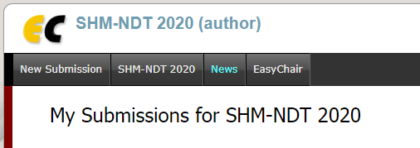

By clicking on New Submission, you will be directed to the Submission page.

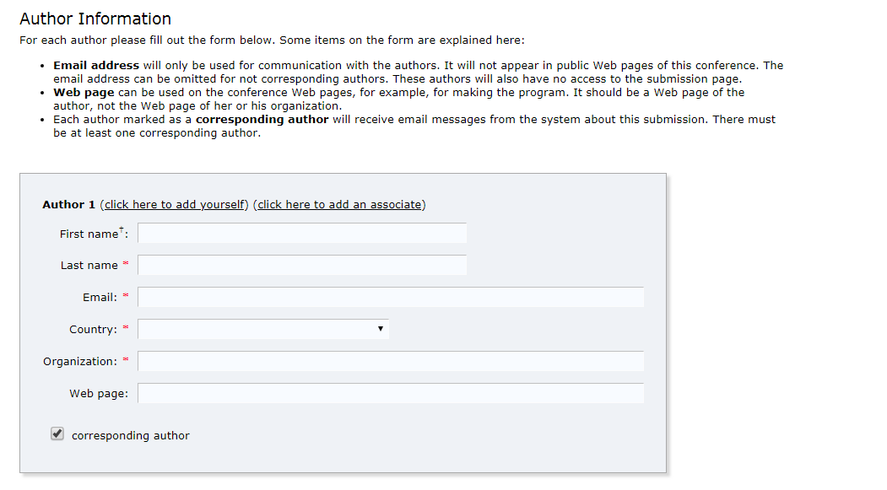
- Enter Author information. You can have as many author as you need in the registration. Make sure to have proper email addresses for corresponding authors. Reviews of submitted papers will be sent through emails to corresponding authors.

- Enter information in the Title and Abstract section. The abstract section should be filled very short summary of the paper.
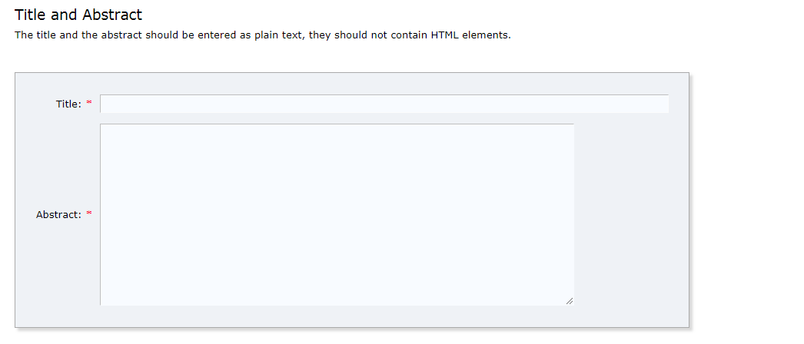

- Enter Keywords in order for us to better classify the paper. Easychair requires 3 keywords on different lines. If you do not have more keywords, you may enter SHM-NDT 2020 in order to fill. See example below.
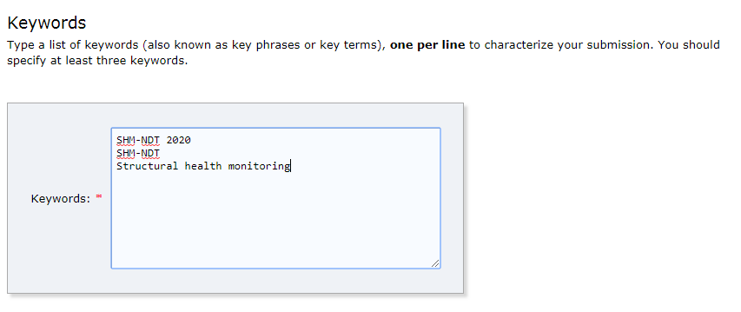

- Select the format of your deposit (Full Paper or Extended Abstract) and upload your file.
The file must be in PDF files.

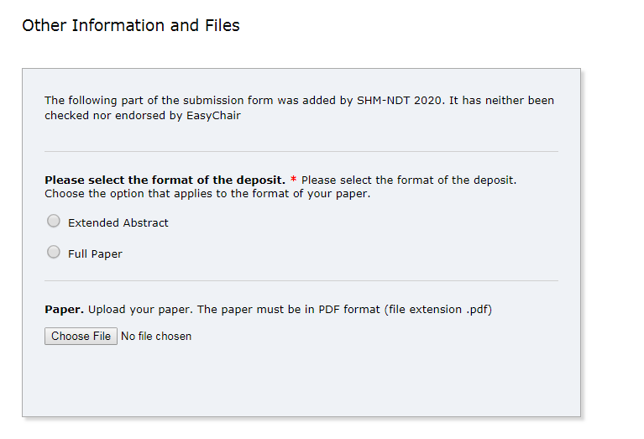
- After all the fields are completed, click on “Submit” to deposit. You will receive an email shortly after submission. If you have more questions, please contact us at :
shmndt2020@easychair.org

